2024–25 SAS Program Assessment Report
Due 6/15/2025 • Submit via e-mail to assess-committee@sas.rutgers.edu
Please see sasoue.rutgers.edu/program-assessment/guidelines for more information.

Department: | Spanish and Portuguese
Program(s):
Submitted by: | Joseph V. Casillas | Date: | 07-01-2025
Assessment Committee Members:

Learning Goals
In this space, please list your program’s learning goals and provide the url where they are posted on your website. Optional: if you have updated or revised your learning goals in the past year, please note those changes here.
Learning goals for the Department of Spanish and Portuguese have not changed since the last assessment. They can be found on our department webpage:
- Spanish: https://span-port.rutgers.edu/learning-goals
- Portuguese: https://span-port.rutgers.edu/portuguese-learning-goals

Shared learning goals

- Majors in all areas will be able to demonstrate proficiency in interpretive, interpersonal and presentational modes of communication and basic knowledge of Linguistics, Cultural Studies or Translation as disciplines.
- The top 75% of Spanish or Portuguese majors will be able to carry out conversations in which they can describe, compare, contrast, in all tenses (present, past and future), with an appropriate breadth of vocabulary and register, and to be understood by a non-sympathetic listener; and to read and write documents written in academic, formal and/or literary registers of language.
- Majors will be able to conduct research projects according to the methodologies of the humanities, social or cognitive sciences and demonstrate intercultural awareness and understanding of the Hispanic or Luso-Brazilian world.
- Honors students (top 15%) will be able to complete independent research, write a thesis, and defend it before a faculty committee.

Spanish-specific learning goals

- Spanish majors who choose electives in Linguistics will also be able to demonstrate familiarity with basic concepts of Linguistics, in particular with issues related to language contact and bilingualism and bilingual education, and be able to design and implement a research project.
- Spanish majors who choose electives in Translation/Interpreting will also be able to demonstrate proficiency at the levels required by pre-professional and professional training for employment in legal, medical, commercial translation and in other areas; and further study in law, medicine, editing/journalism, and business, as well as graduate studies in both linguistics and literature.
- Spanish majors who choose electives in Literature and Culture will also be able to demonstrate knowledge of current issues and perspectives in literary and cultural studies in Spanish and the basic body of works in Spanish literature and culture; critically analyze verbal and visual texts; demonstrate familiarity with a range of cultural works from different time periods and geographical regions within the Spanish-speaking world and with the historical phenomena and socio-cultural issues that these works negotiate.
- The top 15% of majors will be prepared for acceptance to graduate programs in Spanish
- Minors in Spanish will be able to demonstrate a level of language proficiency that allows basic conversations on a variety of uncomplicated topics, with basic command of the language, and some spontaneous creative ability; and basic familiarity with the main cultural, literary and linguistic issues of the Hispanic or Luso-Brazilian world.

Portuguese-specific learning goals

- Portuguese majors will also be able to demonstrate knowledge of current issues and perspectives in literary and cultural studies in Portuguese and the basic body of works in Luso-Brazilian literature and culture; critically analyze verbal and visual texts; demonstrate familiarity with a range of cultural works from different time periods and geographical regions within the Portuguese-speaking world and with the historical phenomena and socio-cultural issues that these works negotiate.
- The top 15% of majors will be prepared for acceptance to graduate programs in Portuguese.
- Minors in Portuguese will be able to demonstrate a level of language proficiency that allows basic conversations on a variety of uncomplicated topics, with basic command of the language, and some spontaneous creative ability; and basic familiarity with the main cultural, literary and linguistic issues of the Hispanic or Luso-Brazilian world.

Are learning goals on syllabi?
How many department/program syllabi include appropriate learning goal statements? (Select one)
Overwhelming majority | More than half | About half | Less than half
Of the 68 syllabi scrutinized from the fall and spring semesters of the 2023-2024 academic year, 100% included appropriate learning goal statements and 90%—the overwhelming majority—also included a direct link to the complete learning goals on the department website.
Where are program learning goals achieved?
In this space, please indicate where in your program students achieve mastery of your learning goals: for each goal, identify which course, group of courses, or other curricular requirement most directly supports student mastery of that goal.
Mastery of a novel or family language does not take place in a single course. For our learners beginning without prior experience, the elementary (101, 102) courses are critical for initiating them in the basics of the present tense and developing skills for intercultural communication. These courses plant the seeds that will eventually allow dedicated students to demonstrate proficiency in various modes of communication, carry out conversations with non-sympathetic listeners, and demonstrate intercultural awareness. In addition, many students come to our program with prior experience, either via previous coursework or familial experience, and are placed accordingly. Importantly, the type of multifaceted knowledge our students obtain is developed over the course of the major/minor, regardless of where a given student begins. Students complete the major by taking 389 (Spanish Lab for Oral Proficiency) and 499 (Oral Proficiency Interview), followed by an official OPI exam.
As mentioned above, our students are expected to read and write documents written in academic, formal and/or literary registers of the language. These skills are developed from the early stages of the program and are given special attention in our 202, 203, and 204 courses (Culture and Composition for Heritage Speakers, Spanish Conversation and Composition, and Culture and Composition, respectively). From there, students can take one of our gateway courses on literature, linguistics, or translation (more below) to begin developing academic writing skills in a specialized area, and also continue to 325/326 (Advanced Grammar and Composition, Advanced Composition and Introduction to Translation Studies). From this point forward, most 300/400-level courses will also require substantial academic writing.
For students focusing on linguistics, cultural studies or translation, our gateway courses (215, 261, and 326, respectively) provide a solid foundation for each area. This foundation is solidified and expanded upon in subsequent 300/400-level courses in which students learn to conduct research projects following the methodologies of the humanities, social or cognitive sciences. From this point forward, students are expected to continue developing as researchers in all of their specialized courses.
Note: this information has not changed since the last assessment.
What question about student learning did your department investigate this year?
In this space, please state the question about student learning that your department investigated this year.

Your question should be useful—answering it should help to inform your department's decisions about curriculum design, instructional practices, student advising, or other factors that impact student learning—and answering it should involve directly examining student learning.

The SAS Assessment Committee’s first priority is ensuring that assessment provides departments with useful information. For guidelines and examples of useful assessment questions, please visit sasoue.rutgers.edu/program-assessment/guidelines or contact SAS Director of Teaching, Learning, and Assessment David Goldman at dgoldman@sas.rutgers.edu.

The question about student learning addressed by the Department of Spanish and Portuguese this year deals with artificial intelligence (AI) for language learning. The use of Large Language Models LLM), such as chatGPT, Gemini, etc., is now commonplace, yet we have little information about how and why our students use these technologies. For this reason, we wanted to know more about if our students are using AI, and, if so, how they are using it. As a department, we believe having knowledge about students’ beliefs, training, and goal regarding AI as a tool for language learning would be helpful for future curricular decisions.

What methods did you use to answer your question about student learning?
In this space, please provide a brief overview of the way your department gathered information about student learning to answer the question posed above.

In the Fall of 2024, we administered a Qualtrics survey to all our enrolled students. The survey aimed to gather information about the following areas:

- Specific training related to AI
- How AI technology is used for coursework
- Usefulness of AI
- Opinions on Department policy regarding AI

What we report in this assessment are the finding from our survey and how we plan to use this information moving forward.

Findings
In this space, please summarize your findings and your interpretation of your findings.

In the Fall semester of 2024, there were 701 students enrolled in Spanish or Portuguese courses. Of these 701 students, only 58 students responded to our survey (8.27% of our total enrollment). These 58 participants were enrolled in 13 distinct courses. Figures 1 and 2 provide a breakdown of the courses from which we obtained data and how they are classified for internal assessment.
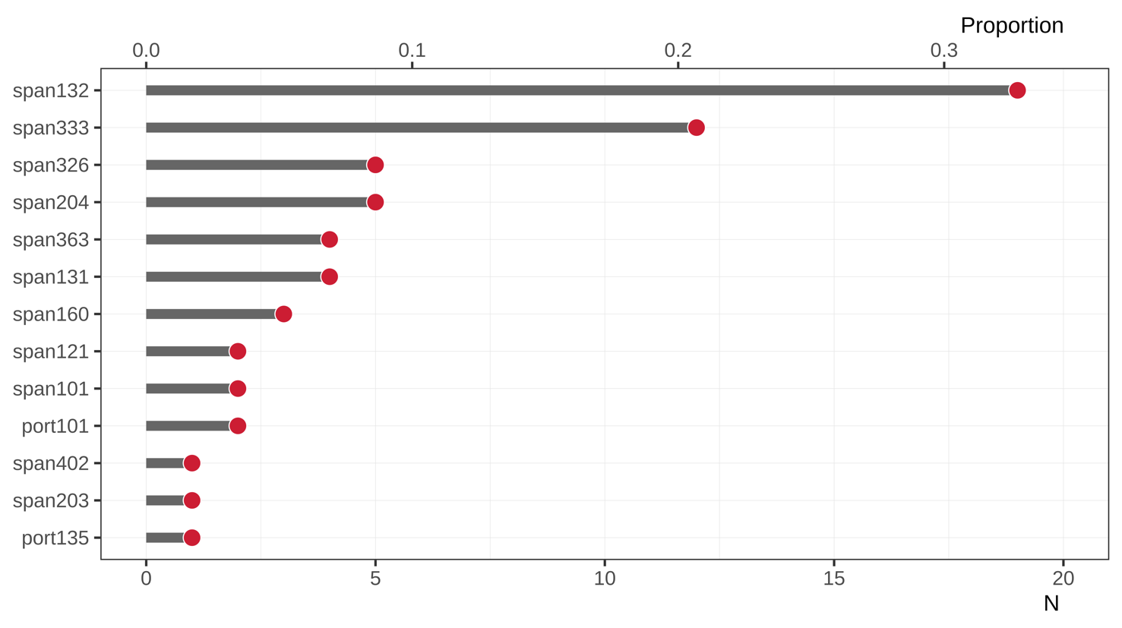
Figure 1: Spanish and Portuguese courses providing data on the Qualtrics survey (N = 58).

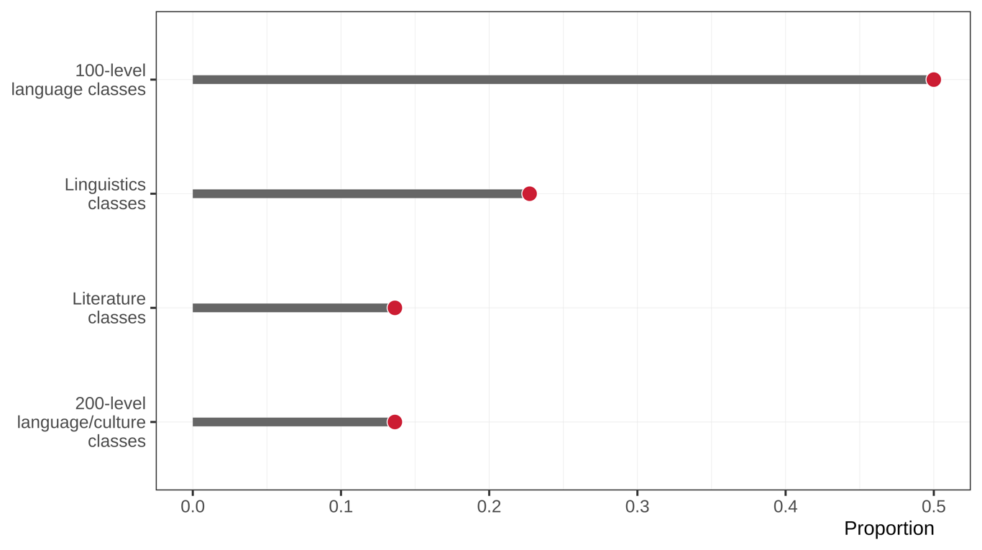
Figure 2: Classification of courses provided data on the AI survey.

Of the 58 respondents, only 4 (approx. 7%) had prior training with AI technologies. Some students mentioned receiving training in their Spanish classes and others received training in courses related to their majors (e.g., computer science). Twenty-seven of the respondents (approx. 47%) reported using AI technologies on at least one assignment in their Spanish class. Figure 3 provides a plot illustrating the types AI technologies used and Figure 4 provides a breakdown of the specific websites and applications.
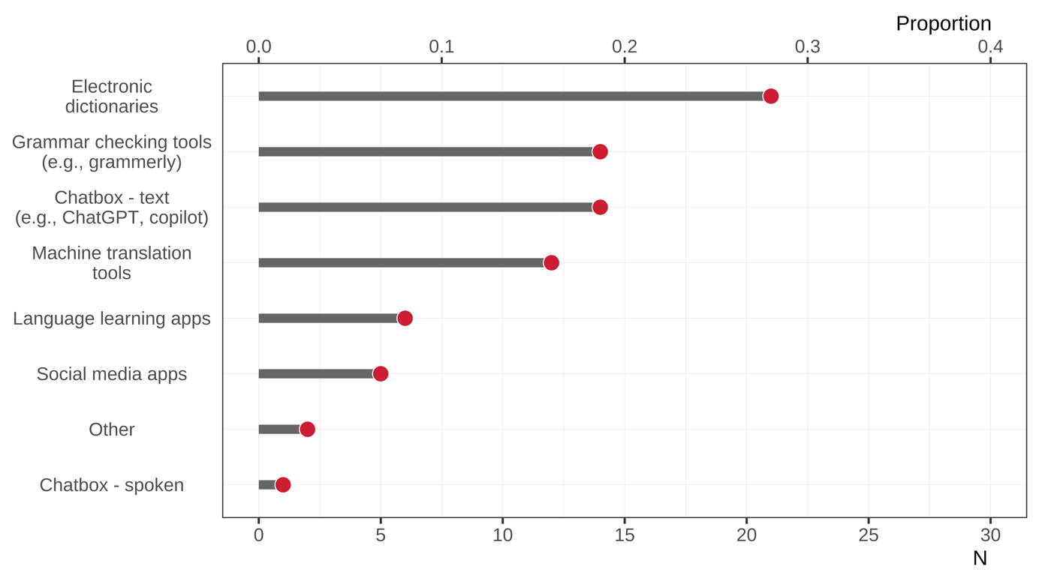
Figure 3: Types of AI technologies used to complete at least one assignment in Spanish or Portuguese classes.

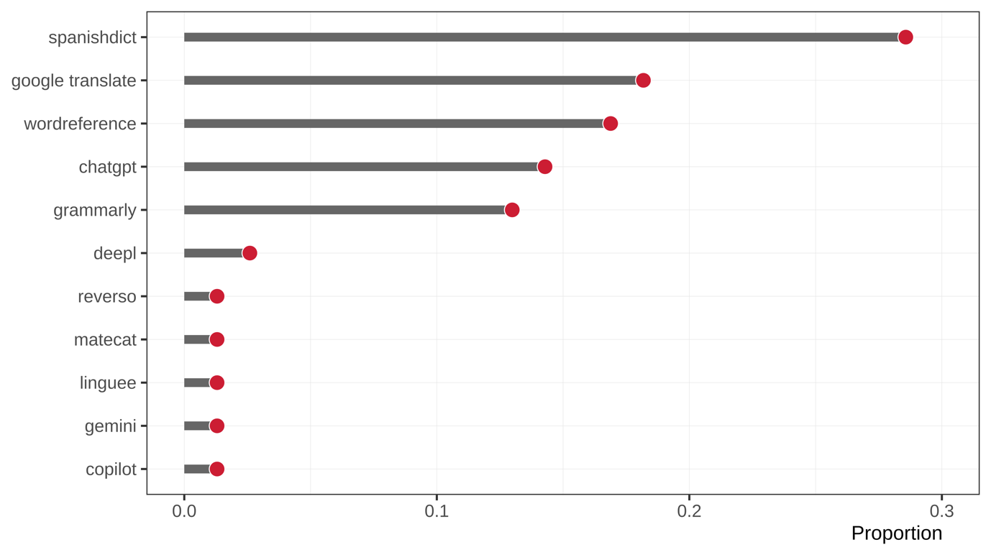
Figure 4: Websites and applications used to complete at least one assignment in Spanish or Portuguese classes.
When asked how their use of AI differed for each of their classes, students reported a range of practices shaped by perceived efficiency, subject matter, and individual preferences. Many described AI as a tool that made academic work more efficient, with one student noting, “It makes things faster. This applies to professors as well.” Usage was largely concentrated in translation and writing-related contexts, while students generally avoided AI in more interpretive or analytical courses like literature and linguistics. As one student put it, “I only used AI for translation courses, not for literature, linguistics, or writing.” Others used AI more creatively, relying on it to assist with idea generation and editing: “I like to use AI to help me with my writing, whether it’s editing or generating ideas for main points.” However, a smaller group expressed skepticism, citing concerns about quality and overreliance: “I don’t really use too much AI because I don’t think it does things as well as a human.” These responses suggest that students are selectively integrating AI tools based on course demands, task type, and their own standards for quality and authenticity.
Regarding their goals for using these technologies, student responses reflect a mix of practical and skill-building motivations. Many emphasized efficiency, using AI to manage time more effectively or complete assignments quickly, as one student put it: “I want to get things done faster.” Others sought support for translation and comprehension, relying on AI to “look up words and outline ideas for presentations.” Writing support was another common goal, with students using AI for grammar checks and sentence refinement: “I use AI to proofread, correct mistakes, and improve my writing over time.” A few students also mentioned using AI for speaking practice, including conversational interaction in other languages, such as one student who noted, “I needed a partner to practice Portuguese.” Together, these responses suggest that students see AI as a flexible tool to support both the mechanics and the meaning-making aspects of language learning.
We also asked student how useful they found AI to be in the language classroom. They responded using a sliding scale that ranged from 0 to 1, where 0 implied “Not useful” and 1 implied “Very useful”. Figure 5 illustrates that the majority of students found AI technologies to be useful with an average rating of 0.86 [0.77, 0.92].
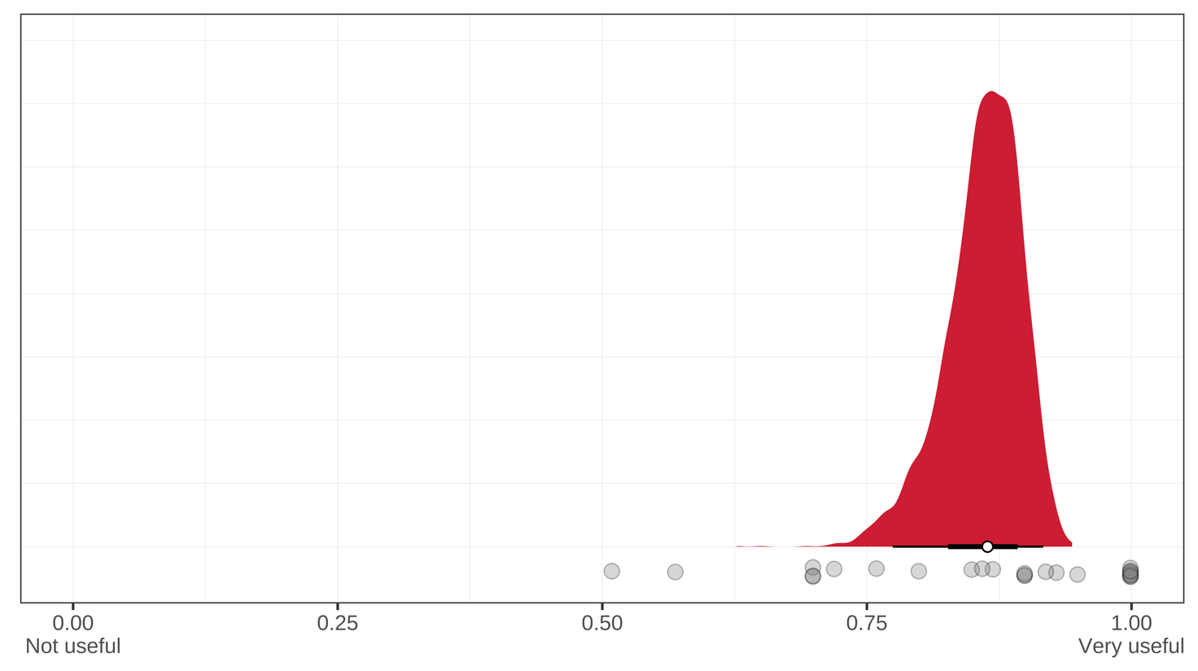
Figure 5: Average usefulness rating of AI technologies in the language classroom. The white point represents the posterior mean along with the 95% credible interval. Transparent grey points represent raw ratings.
Upon analyzing their open-ended responses, we find that students generally viewed AI as a valuable tool in the language classroom, particularly for support with translation, grammar, and self-correction. One student reflected, “Without AI, I would struggle more with assignments,” highlighting its role in boosting academic confidence and task completion. Several students noted that AI tools helped reinforce their learning by confirming conjugations and revealing grammatical patterns, as in the comment, “AI helps confirm my conjugations and gives me confidence to learn.” Others appreciated the variety of explanations AI could offer: “I like that AI explains concepts in different ways.” At the same time, students recognized the limitations of AI, emphasizing the need for human oversight to ensure accuracy: “It is only useful if checked by a human, as it makes errors often.” Overall, responses suggest that while students see AI as an effective complement to their learning, they also understand the importance of using it critically and selectively.
We also asked students what else they would like to be able to do using AI and what features they believe to be missing. They expressed a clear interest in expanding the capabilities of AI tools in areas where current tools fall short. A major theme was the desire for speaking practice, with one student stating, “I would like to engage in spoken conversations in Spanish to practice my skills.” Others emphasized the need for more refined grammar and writing support, including “sentence structure and verb conjugation,” which some felt AI handles imperfectly. Several students also wished for automated study tools, such as “flashcards without extra cost,” to streamline their review and preparation. Finally, students noted a lack of nuance in AI responses, particularly with informal language: “Some colloquial terms are missing in AI responses.” These reflections point to a strong demand for more interactive, accurate, and pedagogically aligned AI features tailored to the needs of language learners.
Finally, we asked students if they thought the Department of Spanish and Portuguese should have a strict policy regarding the use of AI in our classes and, if so, what that policy should be. Many agreed on the need for clearer guidelines. A common position favored guided use, allowing AI for support tasks like proofreading while discouraging overreliance: “AI should be used for proofreading, not for plagiarism.” Others advocated for strict limitations, particularly for assignments designed to assess individual learning: “AI should not be allowed for assignments that require demonstrated learning.” Some students preferred a case-by-case approach, suggesting that policies vary depending on course goals or assignment types: “It should be used for checking work but not for full translations.” Meanwhile, a smaller group opposed any restrictions, viewing AI as a modern learning tool: “Students should be free to use AI as they see fit.”

Please briefly explain how your department has used, or plans to use, the information collected.
In this space, please briefly describe how the assessment results were shared, or will be shared, with the faculty in your department. Then identify your department’s next steps and the timeframe during which your department expects to take its next steps.

The results from the survey were shared with our faculty during a department meeting in the spring 2025 semester. At this stage, the Department of Spanish and Portuguese has not decided on any concrete measures, but we plan to revisit the issue in the fall of 2025. Overall, responses suggest a need for nuanced policy that promotes ethical and educationally sound use of AI without stifling its potential benefits. Based on the findings of this assessment, we see potential for using the report to guide the development of clear, pedagogically grounded policies around AI use that reflect both student needs and instructional goals. Additionally, the data may inform future faculty workshops or course design initiatives focused on integrating AI in ways that support language learning while maintaining academic integrity.

